SOMERSAULT

November 2017

Vol 40, No 6

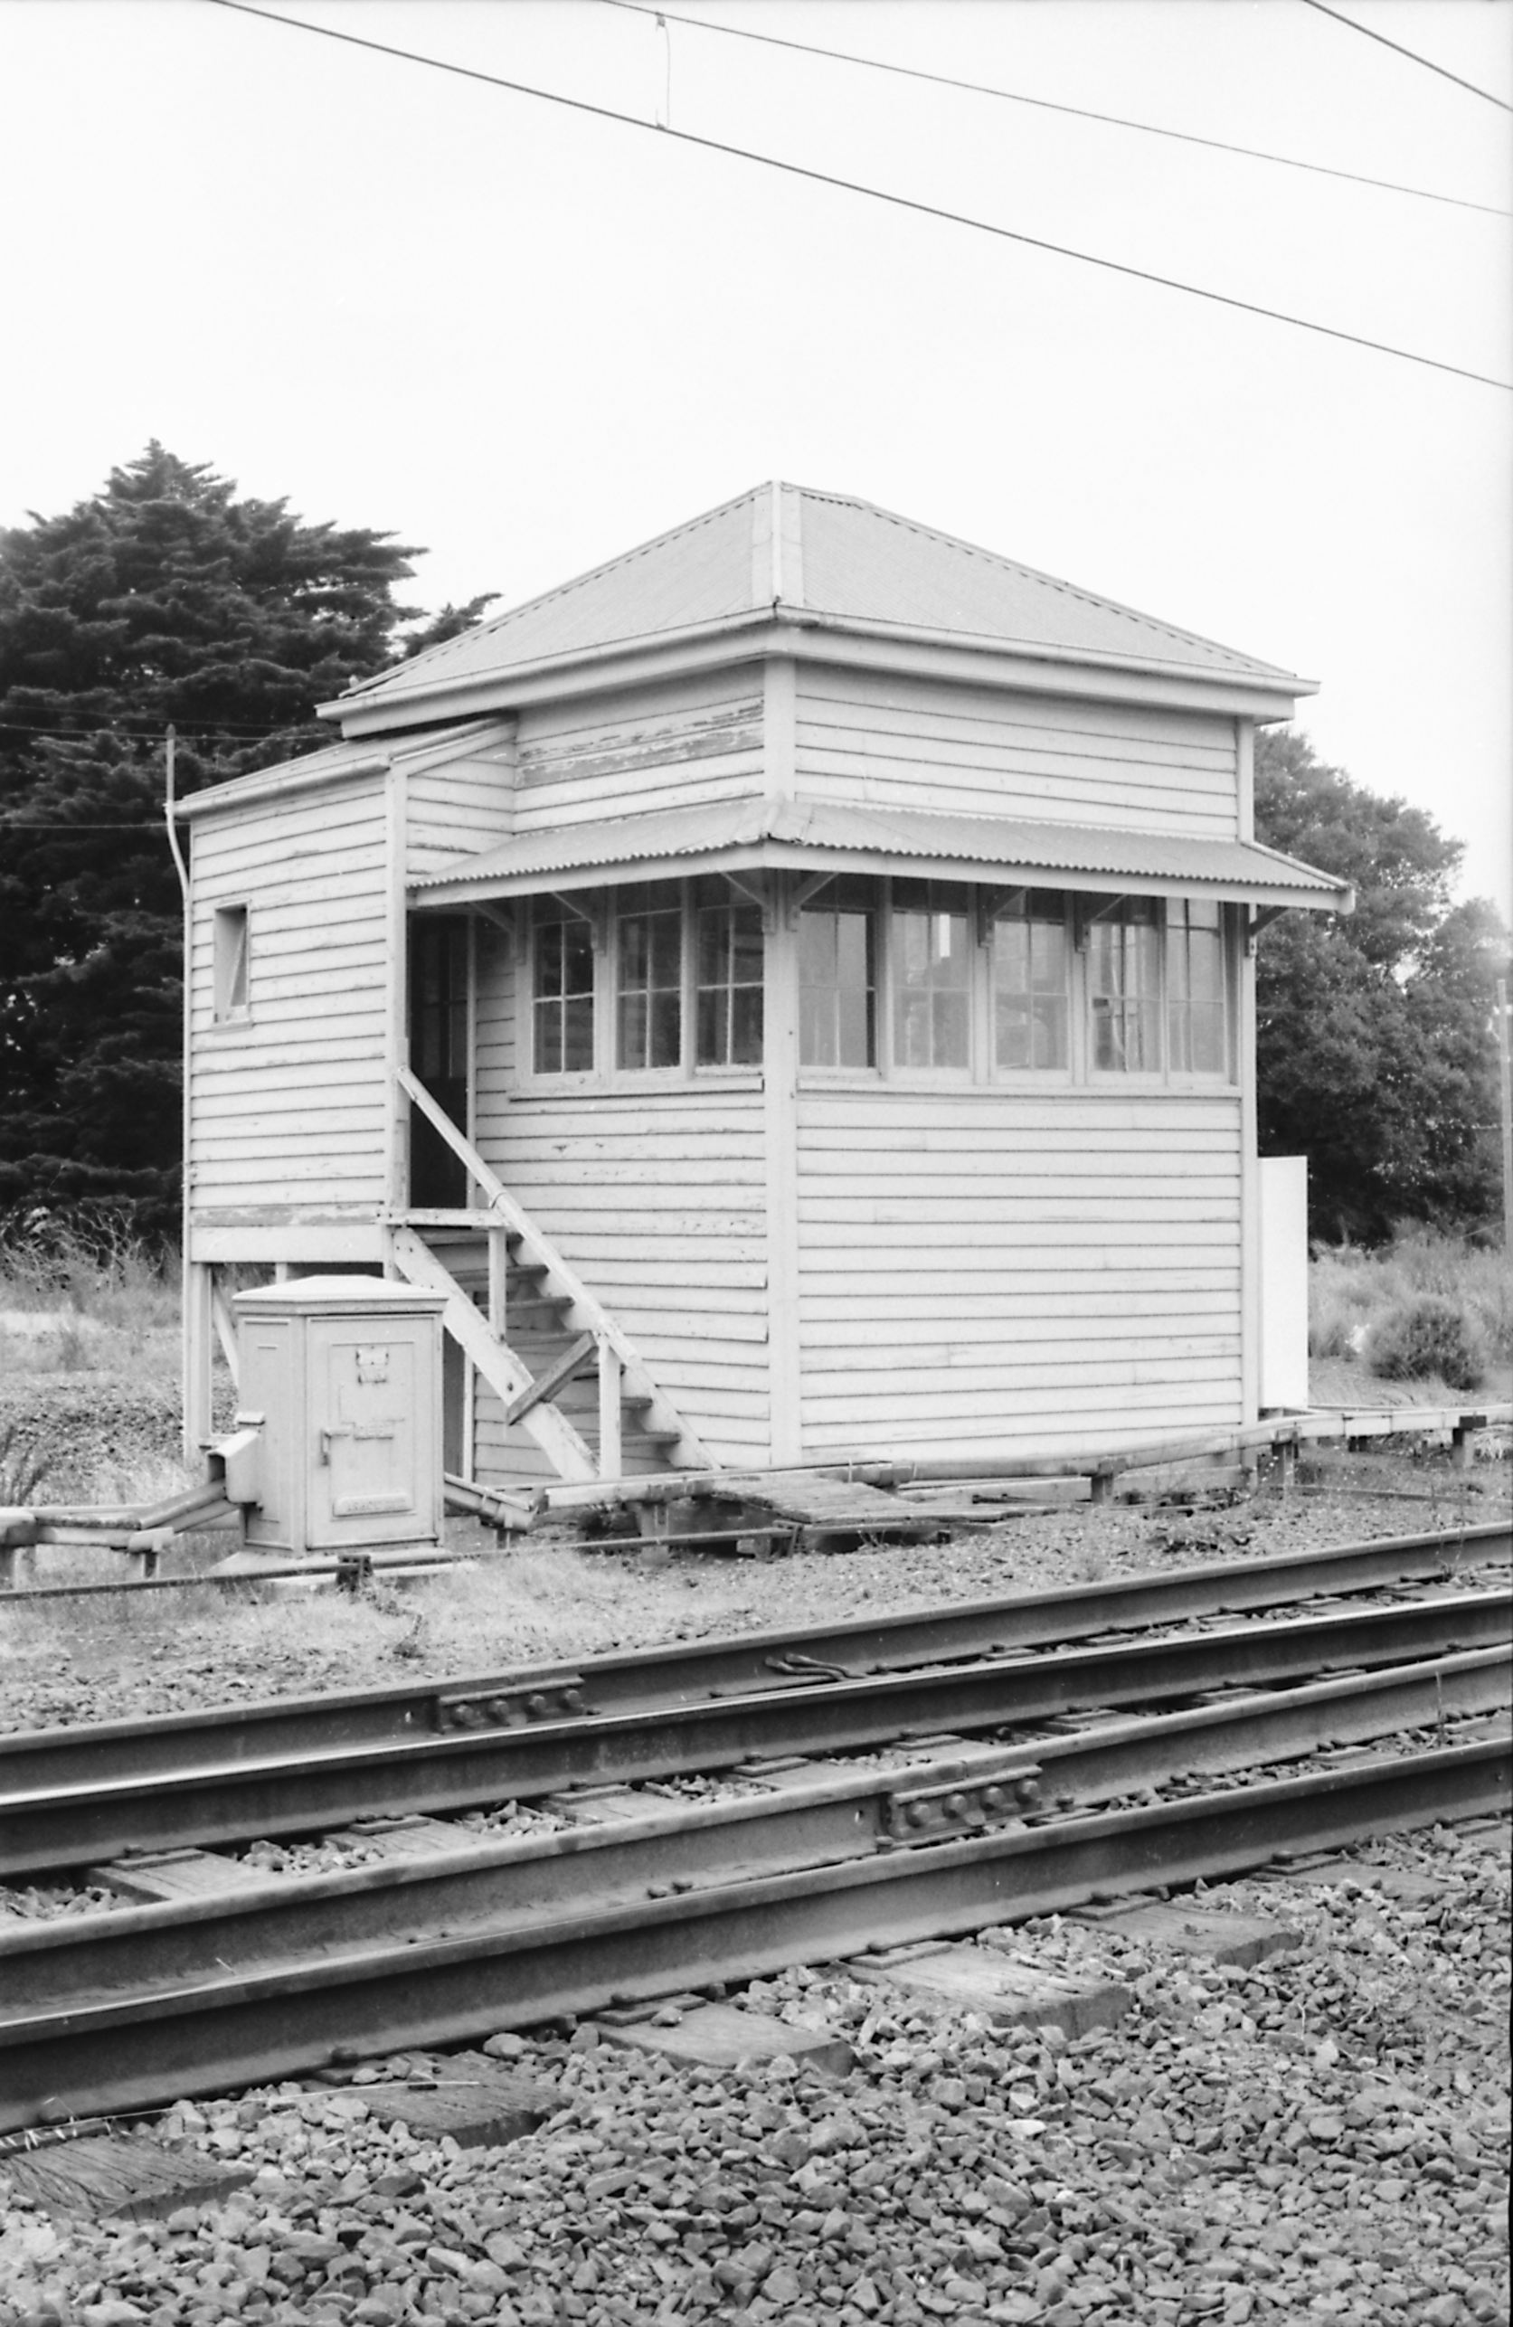Signalling Record Society of Victoria

# Society Contact Information

(Front cover) The first signal box at St Kilda was opened on 7 April 1884, and was noted as containing a 12 lever Saxby & Farmer frame. The cover photo shows the 1884 signal box, and when it was closed in 1987 it was the oldest signal box in Victoria. It was also probably the last of this design opened as subsequent boxes used a gable roof. The Saxby & Farmer frame survived less than six years, it being replaced by a standard 16 lever McKenzie & Holland on 16 February 1890. The frame was extended by two levers on 27 September 1914 due to ‘track alterations’. Three position signals were provided between Flinders St A and St Kilda in December 1919, but St Kilda itself retained mechanical running signals until 28 October 1928. On that date the two mechanical home signals were replaced by three position signals. This allowed the box to switch out with the running signals and points working automatically for arriving and departing trains. The box was switched in for shunting movements, and mechanical disc signals were retained until 1952 when they were replaced by light dwarfs. The box formally closed on 1 August 1987 when the line was closed for conversion to the light rail, but it may have been used during the conversion activities.  
Photo Andrew Waugh

Published by the Signalling Record Society Victoria Inc (A0024029F)

EDITOR: Andrew Waugh, 28 Amelia St McKinnon, VIC, 3204  
Phone (03) 9578 2867 (AH), (03) 9348 5724 (BH), email andrew.waugh@gmail.com

PRESIDENT: David Langley, P.O. Box 8, Avenel, VIC, 3664, Phone (03) 5796 2337

SECRETARY and MEMBERSHIP OFFICER: Glenn Cumming,  
Unit 1/4-6 Keogh St, Burwood, VIC 3125. Phone (03) 9808 0649 (AH)

NSW CONTACT: Bob Taaffe, 63 Hillcrest Rd, Tolmans Hill, TAS, 7007, Phone: (03) 6223 1626

QUEENSLAND CONTACT: Phil Barker  
PO Box 326, Samford, QLD, 4520, Phone: 0400 334403, email: [signal01@bigpond.net.au](mailto:signal01@bigpond.net.au)

Unless articles use copyrighted information, articles may be reprinted without prior permission but acknowledgment is required. Opinions expressed in articles appearing in SOMERSAULT or supplements are not necessarily those of the S.R.S.V. (Inc.)

# Minutes of Meeting held Friday 21 July 2017, At the Surrey Hills Neighbourhood Centre, 1 Bedford Avenue, Surrey Hills, Victoria.

Present: – Glenn Cumming, Graeme Dunn, Michael Formaini, Ray Gomerski, Chris Gordon, Judy Gordon, Andrew Gostling, Bill Johnston, David Jones, Chris King, Keith Lambert, David Langberg, David Langley, Neil Lewis, Andrew McLean, Phillip Miller, Peter Silva, David Stosser, Andrew Waugh and Ray Williams.

Apologies: – Wilfrid Brook, Steve Malpass, Colin Rutledge, Laurie Savage, Rod Smith and Andrew Wheatland.

The President, Mr. David Langley, took the chair & opened the meeting at 20:08 hours.

Minutes of the May 2017 Meeting: – Accepted as read. Michael Formaini / Keith Lambert. Carried.

Business Arising: – The tramway catch points at Glenhuntly have been removed.

Correspondence: – The invoice for the public liability insurance was received and payment has been sent.

Phillip Miller / Neil Lewis. Carried.

Reports: – Tours. Arrangements for the Signal Box tour in September 2017 were discussed.

General Business: – Phillip Miller reported on recent works at Glenhuntly.

David Stosser asked about the operation of pedestrian gates at island platforms when boom barriers were operating. This led to a discussion about laws for level crossings.

The recent major disruption at Metrol was discussed.

Keith Lambert provided details about various works in the Metropolitan District. A summary of the discussion follows: –

* New signals to be provided in October 2017 for the new railway station at Southland. The new station is planned to open to traffic on Sunday 26 November 2017.
* Points at the down end of Frankston are to be converted to motor operation.
* The local control panel at Westona was used during a recent failure.
* The opening of the Heidelberg – Rosanna duplication is planned for Monday 12 February 2018.

Chris Gordon advised that the new Cranbourne Junction is planned for October 2017.

Chris Gordon advised that the Richmond – Burnley re-signalling work is planned for November 2017.

Chris Gordon provided details about level crossing removals planned for late 2017.

Phillip Miller described his observations of the operation of the boom barriers at Chelsea.

David Stosser discussed the announcement of the contract for the Caulfield – Dandenong Line. Two new control centres will be built at Sunshine and Dandenong.

Chris Gordon described a proposal for the re-signalling of the Moorabbin – Frankston Line excluding Moorabbin and Frankston.

Neil Lewis discussed the Mildura Line standardisation project.

David Langberg provided a report on works on the Mernda Line.

Syllabus Item: – The President introduced Secretary Glenn Cumming to present the Syllabus Item in the absence of Roderick B. Smith.

Glenn presented the 27th annual screening of slides from the collection of the late Stephen McLean, carried over from the November 2016 meeting.

This year’s presentation featured Stephen’s first trip to USA and Mexico in December 1981, accompanied by Rod Smith.

Using notes prepared by Rod, the slides showed views of Stephen and Rod’s travels by various Amtrak trains and other operators (e.g. Denver & Rio Grande Western ‘Rio Grande Zephyr on Christmas Day) from Los Angeles to Chicago via El Paso, Mexico, San Diego, Salt Lake City, Denver and Portland.

The loco fans enjoyed shots of classic North American locomotives (e.g. EMD SD45s).

The presentation concluded with Stephen and Rod arriving in Chicago on the Amtrak ‘Empire Builder’ and views of the Chicago South Shore and South Bend.

The next instalment will feature Stephen and Rod’s travels around the Eastern States of the USA and Canada.

The presentation was enjoyed by those present.

At the completion of the Syllabus Item, The President thanked Glenn (and Rod for the preparation) for the entertainment & this was followed by acclamation from those present.

Meeting closed at 22:34 hours.

The next meeting will be on Friday 15 September, 2017 at the Surrey Hills Neighbourhood Centre, Bedford Avenue, Surrey Hill, commencing at 20:00 hours (8.00pm).

# Minutes of Meeting held Friday 15 September 2017, At the Surrey Hills Neighbourhood Centre, 1 Bedford Avenue, Surrey Hills, Victoria.

Present: – Ken Ashman, Phil Barker, Glenn Cumming, Graeme Dunn, Ray Gomerski, Chris Gordon, Judy Gordon, Graeme Henderson, Bill Johnston, David Jones, Keith Lambert, David Langberg, David Langley, Neil Lewis, Andrew McLean, Phillip Miller, Colin Rutledge, David Stosser, Bob Taaffe and Andrew Wheatland.

Apologies: – Robert Bremner, Wilfrid Brook, Michael Formaini, Chris King, Steve Malpass, Michael Menzies, Laurie Savage, Brian Sherry, Rod Smith and Andrew Waugh.

Visitor: – David Isherwood.

The President, Mr. David Langley, took the chair & opened the meeting at 20:00 hours.

Minutes of the July 2017 Meeting: – Accepted as read. Phillip Miller / Bill Johnston. Carried.

Business Arising: – Nil.

Correspondence: – Letter sent to David Ward at Metro Trains seeking permission for the Signal Box tour on Saturday 16 September 2017.

The invoice for the “Signalling Record” for 2016 was received from the SRSUK and payment was sent.

Phillip Miller / David Stosser. Carried.

Reports: – Tours. Final arrangements for the Signal Box tour in September 2017 (tomorrow) were discussed.

General Business: – Keith Lambert provided details about various works in the Metropolitan District. A summary of the discussion follows: –

* New signals for the new railway station at Southland will be commissioned this weekend.
* A six (6) day occupation between Springvale – Pakenham and Dandenong – Cranbourne starts next week.
* A four (4) week occupation between Coburg – Upfield commences in mid November 2017 for level crossing removal works.
* A five (5) week occupation between Clifton Hill – Macleod is planned for level crossing removal works.
* Public Transport Victoria (PTV) will take responsibility of the Victorian railway rule book in July 2018.
* PTV plan to issue a new Victorian railway rule book in 2019.

Chris Gordon advised that Fairfield – Alphington will be converted to single line between February 2018 – May 2018. The signalling will be controlled from Epping. Control of signalling at Heidelberg and Macleod will be transferred to Epping.

Ken Ashman reported that the McKenzie and Holland style “A” power frame at Pukekohe New Zealand will be replaced by a “Westrace” computer based interlocking on 18 November 2017.

Ken Ashman noted that when this work is completed, the frames remaining in New Zealand will be at Wellington “A” Box, Tawa, Plimmerton and Addington.

Ken Ashman expressed his thanks to Andrew Waugh for his continued good work in editing “Somersault”.

Keith Lambert advised that the Richmond – Burnley resignalling will be commissioned over five days starting on Thursday 30 November 2017. Control of Burnley will be transferred to Metrol. No trains will run during this period and EIGHTY buses have been booked to provide replacement services.

Colin Rutledge provided details about various works in the country districts. A summary of the discussion follows: –

* V/line has started planning to run Velocity railcars to Bairnsdale.
* Substantial works are planned for the Avon River bridge at Stratford.
* Further level crossing protection works around the state were described.
* The Maryborough – Ararat Standard Gauge Line is scheduled to open on 2nd January 2018.

A lengthy discussion about the North West Standard Gauge project followed. Sidings for track machines will be provided at Curyo and Mildura.

Graeme Henderson reported that the Newcastle NSW interchange opens next weekend and will be in use from late November 2017.

The works at Hornsby NSW were discussed.

Ken Ashman described new container sidings at Hamilton NZ.

Ken Ashman reported on signalling failures on the NZ North Island East Coast Main Trunk last weekend caused by multiple lightning strikes.

Keith Lambert noted that Murrumbeena railway station will reopen after construction works for the new elevated line and Hughesdale railway station will be demolished.

Syllabus Item: – The President introduced Secretary Glenn Cumming to present the Syllabus Item.

Glenn presented a series of images taken during the first week of a visit to Western Australia in March 1996.

Images of railway signalling at locations from Picton Control in the South to Port Hedland in the North were viewed including Narrogin, Claremont, Perth Control and Midland were seen.

The presentation was enjoyed by those present.

At the completion of the Syllabus Item, The President thanked Glenn for the entertainment & this was followed by acclamation from those present.

Meeting closed at 22:30 hours.

The next meeting will be on Friday 17 November, 2017 at the Surrey Hills Neighbourhood Centre, Bedford Avenue, Surrey Hill, commencing at 20:00 hours (8.00pm).

# Signalling Alterations

The following alterations were published in WN 36/17 to WN 42/17, and ETRB A circulars. The alterations have been edited to conserve space. Dates in parenthesis are the dates of publication, which may not be the date of the alterations.

31.08.2017 Rainbow (TON 87/17, WN 37)

On 31.8., the Down end main line points (428.625 km) were booked back into service.

(05.09.2017) Book of Rules – Section 15 Rule 5 (SW 122/17, WN 36)

Section 15 Rule 5 has been altered for the V/Line regional network.

Track works, or any other track activity that fouls or may foul the railway either on or in the air space, must not be protected by signals alone. In addition to the signals being kept at stop, the work must be protected by: absolute occupation (Section 15 Rule 9), track warrant (Section 34 – 135 No 21); track force protection (Section 15); or protective local signal blocking (SW 30/17).

SW 134/08 is cancelled.

11.09.2017 East Melbourne – Burnley (SW 262/17, WN 36)

On Monday, 11.9., the new 2.2 kV UPS signal power supply will be tested between the East Melbourne and Burnley substations.

(12.09.2017) Automatic level & pedestrian crossing failures on Metrol network (WN 37)

The procedures relating to the failure of automatic level crossings in Clause 4.3 of L1-SWS-PRO-099 (Road and rail traffic management at Metropolitan level crossings) have been amended. The instructions in Book of Rules, Section 9, Rules 1E, 1F, 1G, & 1H will not apply on the Metro Network.

The Signal Fault Centre is responsible for co-ordinating all arrangements at level and pedestrian crossings during failures and disruption to train services.

Right side failure of automated level crossing protection equipment

(a) Level crossing to remain open to road traffic protected by Automatic signals

Where the level crossing is to remain open, the Signal Fault Centre will arrange for Road Traffic Management to be implemented at the level crossing. A Track Force Protection Co-ordinator will be provided to manage the rail and road traffic at the level crossing.

The automatic signals on each approach to the level crossing must be secured at Stop. The boom barriers can be latched up once the protecting automatic signals have been secured at Stop.

The drivers of rail movements must be advised by a CAN Warning Notice that the operation of the level crossing is being co-ordinated under Road Traffic Management.

(b) Level crossing protected by Home or Dwarf signals

Where the level crossing is to remain open, the Signal Fault Centre will arrange for Road Traffic Management to be implemented at the level crossing. A Track Force Protection Co-ordinator will be provided to manage the rail and road traffic at the level crossing.

The Signaller must keep the protecting signals at Stop. The boom barriers can be latched up once the Signaller has confirmed with Co-ordinator that the signal levers have been sleeved normal.

Where possible, the protecting signal must be cleared for each rail movement. Where this is not possible, the appropriate authority must be issued by the controlling Signaller to pass the signal at Stop.

The drivers of rail movements must be advised by a CAN Warning Notice that the operation of the level crossing is being co-ordinated under Road Traffic Management.

(c) Level crossing not protected by fixed signals

Where the level crossing is to remain open, the Signal Fault Centre will arrange for Road Traffic Management to be implemented at the level crossing. A Track Force Protection Co-ordinator will be provided to manage the rail and road traffic at the level crossing.

Track force protection must be applied on each approach to the crossing. The boom barriers can be latched up once the track force protection is in place. Latching up of the boom barriers must only be performed by a Signal Maintenance Technician.

The drivers of rail movements must be advised by a CAN Warning Notice that the operation of the level crossing is being co-ordinated under Road Traffic Management.

(d) Automated pedestrian crossing protection equipment

The management of a failed automated pedestrian crossing is not contained in L1-SWS-PRO-009. The following procedures must be observed.

If possible, the pedestrian crossing should be closed to pedestrians.

The pedestrian crossing must not remain open unless all of the following conditions are met:

* Any approaching train can be seen for at least 25 seconds
* A Track Force Protection Co-ordinator is present on one side of the crossing to control the passage of pedestrians, and a second competent person is present on the other side of the crossing to control pedestrians at that side.

Wrong side failures of level or pedestrian crossing equipment

Rail movements must not be permitted to approach an automated level crossing or pedestrian crossing until the crossing has been protected as described above.

(12.09.2017) Warrnambool – Westvic Siding (SW 123/17, WN 37)

Signalling Diagram 30/17 (Warrnambool – Westvic Siding) replaced Diagram 46/14 as in service.

(12.09.2017) Eaglehawk - Raywood (SW 124/17, WN 37)

Signalling Diagram 16/16 (Eaglehawk - Raywood) replaced Diagram 12/13 as in service.

(19.09.2017) Track Warrants (SW 125/17, WN 38)

Section 35 Operating Procedure 135-21 (Track Warrants) has been reissued. This Operating Procedure only applies to the V Line Operated Network. The alterations affect the:

* Conditions under which a Track Warrant cannot be issued.
* Requirement that both the Person in Charge of the worksite and the Track Force Protection Co-ordinator are to sign the Track Warrant prior to it being returned.
* Issuing of Track Warrants that cover multiple controlled areas or safeworking systems.
* Issuing of Track Warrants in defined station limits.
* Issuing of Track Warrants for reactive maintenance on the RFR lines.
* Protection arrangements in Train Order Territory at attended signalling locations.

19.09.2017 Highett – Cheltenham (SW 267/17, WN 36)

Between Saturday, 16.9., and Tuesday, 19.9., the signalling for the new Southland station was commissioned.

The alterations were:

* Southland station was provided at 21.440 km. It has two 160 metre platforms. The expected opening date of Southland station is 26.11.2017.
* Down Automatic F627 and Up Automatic F622 were converted to LED
* Down Automatic F643 and Up Automatics F634, F648, & F670 were provided. Each was equipped with TPWS (TSS).
* Up Automatics F662 & F642 were abolished
* Down Controlled Automatic 2 (F655) was renewed and relocated. It was equipped with TPWS (TSS).
* The panel at Cheltenham was altered to reflect these changes.
* The commissioning of the automatic pedestrian gates at Heather Grove was delayed.
* The express/stopping selection for Southland station and Heather Grove will set to express operation until the opening of the station.

Diagram 7/17 (Glenhuntly – Southland) replaced 1/16 (Glenhuntly – Mentone).

22.09.2017 Tocumwal (SW 128/17, WN 38)

On Friday, 22.9., the “End” and “Commence” Train Order Working Boards were relocated 239 metres in the Down direction to 250.552 km (between the Murray River bridge and Bridge Street). The Down location board will not be relocated. The hand operated derail block and sign at 250.942 km (see TON 179/12) were abolished. Amend Diagram 48/10 (Congupna – Tocumwal).

25.09.2017 Burrumbeet – Trawalla (SW 133/17, WN 39)

On Monday, 25.9., hand gates were provided on both sides of the line at Modesty Lane (146.469 km) between Burrumbeet and Trawalla. The gates are locked across the road, and keys are held by the land owner, local service providers, and asset management staff. The existing Stop signs were retained. Amend Diagram 2/16 (Wendouree – Beaufort).

02.10.2017 Axle counter reset procedures on the MTM network (SWP 11/17, WN 39)

On Monday, 2.10., Metro Trains General Operating Procedure 14 (Axle Counter Reset Requirements) was reissued. The amendments concerned the processes for undertaking a manual axle counter section reset (clauses 5 & 5A), a reset during or after an Absolute Occupation (clause 6) and a reset after works under Track Force Protection (clause 7).

02.10.2017 Murrumbeena (SW 289/17, WN 39& 40)

From 0400 hours on Monday, 2.10., this station was reopened for suburban passenger traffic. The stopping/express selection for Murrumbeena Rd was reinstated.

05.10.2017 Newport (SW 293/17, WN 40)

Between Monday, 2.10., and Thursday, 5.10., Points 608D, 610D, and 611 were provided with M23A dual control point machines. The selector lever will be locked in the motor position by signal maintenance padlocks. Amend Diagram 13/15 (Newport).

05.10.2017 Yelta (SW 139/17, WN 41)

On Thursday, 5.10., the absolute occupation was extended from the Train Order Working Boards to the baulks at the end of the track.

05.10.2017 Murrayville (SW 139/17, WN 41)

On Thursday, 5.10., the absolute occupation was extended from the Up end points to the baulks at 581.500 km.

07.10.2017 Panmure (SW 136/17 & 138/17, WN 40 & 41)

On Saturday, 7.10., boom barriers were provided at the passive crossing at Vickers Rd (238.153 km). The boom barriers are operated by axle counters. Healthy state indicators, yellow whistle boards, and remote monitoring equipment was provided. A reset keyswitch is provided for the crossing track.

Diagram 50/17 (Panmure – Sherwood Park) replaced 49/17.

07.10.2017 Long Island Line – Cresco Siding (SW 297/17, WN 41)

On Saturday, 7.10., the Metro leased portion of the lead to the Cresco Siding was restored to service. SW 99/16 was cancelled.

08.10.2017 Winchelsea (SW 137/17, WN 40)

On Sunday, 8.10., boom barriers were provided at the passive crossing at Ondit Rd (116.199 km). The boom barriers are operated by axle counters. Healthy state indicators, yellow whistle boards, and remote monitoring equipment was provided. A reset keyswitch is provided for the crossing track.

Amend Diagram 24/17 (Moriac - Winchelsea)

09.10.2017 Track Warrants (SW134/17 & 291/17, WN 39)

Effective Monday, 9.10., the instructions for issuing a Track Warrants to the VLine/Metro lease boundaries at Werribee – Manor Junction, Pakenham – Bunyip & Sunbury - Gisborne were reissued. SW 132/17 & 283/17 were cancelled.

10.10.2017 Epping (SW 282/17, WN 42)

On Tuesday, 10.10., a SPAD Alert Board was installed next to the Down line 400 metres on the approach to EPP110 as a trial. The Board is to remind Drivers that they are approaching EPP110, which is a multiple SPAD signal. The Board is a white with blue lettering. At the top is the word ‘ALERT’, in the middle is a symbol representing a three aspect signal, and at the bottom is the text ‘EPP 110’ and ‘400m’.

10.10.2017 Moorabbin (SW 296/17, WN 41)

On Tuesday, 10.10., Home MRN702 was converted to LED.

11.10.2017 North Dynon (SW 173/17, WN 41)

On Wednesday, 11.10., No 11 track was provided in the Agents Sidings area. This track leads off the No 3 Fuel Point track at new Points VTD58. The siding has a clear standing length of 650 metres.

Points VTD70 were provided in K Track. These are operated by a WSa lever and will be secured for K Track.

Amend Diagram 37/14 (South Kensington).

12.10.2017 Highett – Cheltenham (SW 301/17, WN 41)

On Thursday, 12.10., automatic pedestrian gates at Heather Grove were commissioned.

13.10.2017 Woodvale (SW 141/17, 148/17 & 149/17, WN 41 & 42)

On Friday, 13.10., boom barriers were provided at the passive crossing at Rileys Rd (177.903 km). The boom barriers are operated by axle counters. Healthy state indicators, yellow whistle boards, and remote monitoring equipment was provided. A reset keyswitch is provided for the crossing track.

Diagram 46/17 (Eaglehawk – Raywood) replaced 16/16.

14.10.2017 Dunolly (SW 144/17, 153/17, & 158/17, WN 41 & 42)

On Saturday, 14.10., Dunolly was closed as an unattended Train Order Crossing Station and became an Intermediate Train Order Station.

No 2 Road was abolished and all trains will operate via No 1 Road. Points DLY7at the Up end of the Crossing Loop will be removed, including the point machine and banner. Points DLY 27 at the Down end of the Crossing Loop will be secured reverse and the point banner will be abolished.

Points A, at the Up end of the yard, with rodded connections to Nos 3 & 4 Rds will remain secured normal. Points E, F, and G (all leading from No 2 Road) were abolished. Points H at the Down end of No 1 were abolished together with the rodded connections leading to Siding D.

The gauge transfer on the Up side of Points A was abolished. The gauge transfer in No 1 Road at the Up end of the platform was removed.

No change was made to the signals, except that Home DLY28 will now apply to moves to No 1 Road.

Diagram 42/17 (Dunolly) replaced diagrams 136/11 and 70/13. Operating Procedure 84 (Dunolly) was reissued and SW 154/17 was cancelled.

14.10.2017 Carnegie (SW 229/17, WN 41)

From Saturday, 14.10., Carnegie was temporarily closed. The stopping/express selection for Koornang Rd was disabled and all Up and Down trains will operate under express conditions between Caulfield and Murrumbeena. The station is expected to reopen on Monday, 20.11.17.

14.10.2017 Hughesdale (SW 290/17, WN 40)

On 2030 hours on Saturday, 14.10., Hughesdale station was temporarily closed. The station buildings and platform will be demolished to allow for construction of the viaduct.

The Down side pedestrian crossing at Poath Rd was permanently closed to public use. Pedestrian gates 8, 9, & 10 will be removed. Pedestrian gate 7 (on the Down side of the line) will remain in use by construction workers.

The stopping/express selection for Poath Road will be disabled. All Up and Down trains will operate under express conditions between Murrumbeena and Oakleigh. The Signallers at Caulfield and Oakleigh (when switched in) are to operate the stopping/express selection for each train as per the working timetable.

(17.10.2017) Absolute Occupation (SW 307/17, WN 42)

Pending a full review, the following additional protection is required at the boundary of an Absolute Occupation (L1-OPS-PRO-15). All tracks providing an exit at the boundary of an Absolute Occupation must be protected with a “Stop” board or a Flagman and ATWs. Where the Flagman is protecting the entrance to an Absolute Occupation, they can also protect an adjacent exit. This alteration is to ensure that workers can easily identify the boundary and rail movements do not proceed beyond the Absolute Occupation limits.

(17.10.2017) Use of Lookouts (SW 145/17, WN 42)

Operating Procedure 135 (Supplementary Infrastructure Procedures), No 23 (Use of Lookouts) was reissued. SW 12/17 was cancelled.

(17.10.2017) Geelong Locomotive Depot (SW 150/17 & 151/17, WN 42)

A new ‘Limit of Shunt’ board and sleeper mounted stop sign has been provided on the Arrival Track, 50 metres on the Down side (further out) than the previous ‘Limit of Shunt’ board. Amend Diagram 8/11 (Geelong).

Operating Procedure 61 (Geelong) was reissued. SW 67/16, and IMS document NOWI-18 were cancelled.

(17.10.2017) Marshall (SW 152/17, WN 42)

Signalling Diagram 36/17 (Marshall) replaced 88/14 as in service.

(17.10.2017) Heathcote Junction – Kilmore East (SW 146/17, WN 42)

Diagram 40/16 (Heathcote Junction – Kilmore East) replaced 14/16 as in service.

19.10.2017 Ringwood East – Croydon (SW 311/17, WN 42)

On Thursday, 19.10., Automatic H942 was converted to LED.

20.10.2017 Clayton (SW 310/17, WN 42)

On Friday, 20.10, the automatic pedestrian gates on the Down side of Clayton Road were restored to service.

23.10.2017 Book of Rules Section 15, Rule 7 (Warning and Caution Boards) (SW 157/17, WN 42)

From Monday, 23.10., Book of Rules, Section 15, Rule 7 (Warning and Caution Boards) will not apply to the VLine Operated Network. Operating Procedure 135 (Supplementary Infrastructure Operations) was reissued to include instructions for the application of Warning and Caution Boards on the VLine network.

23.10.2017 Camberwell (SW 308/17, WN 41)

Between Saturday, 21.10., and Monday, 23.10., Points 204, 207, 217, 226D, & 227, and Crossovers 214, & 224 were provided with M23A dual control point machines. Signallers may operate these point machines in hand mode. Amend Diagram 77/13 (Auburn – East Camberwell).

End£

# Collision at Riddells Creek 4 September 1876

In the evening of Monday, 4 September 1876, an Up Goods train which was shunting at Riddells Creek was run into by a following Up Stock Special. The collision occurred at 9.17 pm. The night was clear and moonlit.

The line was double and the trains were running under time interval working. From just out of Gisborne the line falls continuously into Riddells Creek. The gradient is at first gentle, at 1 in 108 falling. Then follows a little over one mile of 1 in 57. The gradient then eases for about three quarters of a mile. Then follows about one and a half miles of 1 in 56 falling grade which ends at the Riddells Creek bridge, just before the station.

The regular Up Goods train left Sandhurst at 4.20 pm with fourteen trucks loaded with grain and firewood. It arrived at Riddells Creek at 9.05 pm and proceeded to shunt under the direction of the Station-master, Guard, and Porter. The Guards Van and tail of the train was left standing on the Up main line. The station semaphore, on the platform, was placed to danger to protect the train. The four tail lamps on the Guards Van were lit.

While shunting, the driver of the train, Jones, noticed the lights of the oncoming train. He immediately called out to the Guard, Seavol, to hook up the detached part of the train standing on the main line. This was not possible, and Jones put on steam and drew the portion of the train attached to the engine forward and out of the way of the collision. No doubt the Station-master, Guard, and Porter scattered.

The live stock special, consisting of 25 trucks of sheep and two brake vans, each with a Guard, had been following the goods from Sandhurst. The special left Woodend 35 minutes after the regular goods. The special was completely hand braked, and the usual practice was for heavy trains to come to a stand at the top of the descent into Riddells Creek to pin down hand brakes.

Driver Douglas of the special admitted seeing the red light in the semaphore, and the four red lights on the rear of the Guards Van immediately the train came around the curve at the foot of the grade. However, the train was travelling too fast to pull up, even though the two Guards and the locomotive crew applied the hand brakes.

The results were spectacular, and fortunately without loss of life or serious injury.

The whole space between the platforms was filled with the wreckage of the wagons and Guards Van, as well as ‘sheepskins and goods of all descriptions’. The Age described grain knee deep in places, and hundreds of bushels of dried peas. The engine tender (of the special), the Guard’s Van, one coal, one sheep and three goods wagons were completely destroyed, and three other goods wagons were damaged. The engine of the stock special ended up on its side on the Up platform, broadside to the line, with its smokebox door adjacent to the booking office door. Its driver had a lucky escape, being uninjured, as he remained on the locomotive until it came to rest. His Fireman, Williams, jumped off the locomotive about 50 yards before the collision and received severe bruising and a cut on his head. It was noted that he was delirious when he returned to Melbourne. Newspaper reports noted that the sheep had a lucky escape – of the 2000 on the train only about 20 were killed.

An initial report by John Anderson, the Assistant Traffic Manager, was submitted to the Commissioner (Minister) on 6 September which stated “driver Douglass was well aware that he was following close a timetable train, so that the unavoidable conclusion is, that he was running too fast, and had not his train under control. […] With this information at present in my possession, I do not feel justified in saying that the driver is solely to blame for this accident, but inquiries are being made, and when they are completed, a further report on the subject will be furnished, with recommendations as to avoiding similar calamities in future.”

The formal investigation was undertaken by Thomas Higinbotham (Engineer-in-Chief), William Meikle (Locomotive Superintendent), and John Anderson. It reported to the Commissioner on 5 October 1876 as follows:

Sir. — In accordance with your memo., dated the 20th ult. [September], instructing us— First, To investigate and report upon all the causes which have contributed to the above-mentioned serious accident; and second, to report upon the several methods suggested, and any others which we may think proper for the prevention of such accidents in future, we have the honor to report that : —

First.— We have investigated the causes of the accident referred to, and are of opinion that it was caused by the neglect to apply a sufficient number of brakes to the special sheep train which left Woodend at 8.45 p.m. on the evening of the 4th September last, and ran into a goods train standing at Riddell's Creek station on the same evening at 9.20 p.m. There was ample brake power provided for the sheep train, as, in addition to two heavy brake vans, there was a brake on every one of the twenty-five trucks of which the train was composed. Only nine of these truck brakes, however, were dropped, six were used for descending the Macedon bank, and three additional brakes were dropped before the descent of Riddell's Creek bank was commenced. It is in evidence that with the brake power employed the sheep train could have been stopped in 100 yards beyond the point at which the collision occurred. There can therefore be no doubt that if even fifteen truck brakes had been dropped at the top of Riddell's Creek bank the collision with the goods train would have been avoided. The sheep train was drawn by goods engine No. [5?]3. which was driven by William Douglas, the name of his fireman being William Williams. There were two guards in charge of the train, each having his own van. The name of the head guard is Edward Murphy and the second guard's name is William Butters. As soon as the tail lights of the goods train, which was standing at Riddell's Creek station, were observed, Douglas and his fireman and the two guards made every effort to pull up the sheep train before it came into collision with the goods train; the accident did not therefore occur in consequence of any want of effort on their part to stop the train when they became aware of the danger, but it arose, as already stated, from neglect to use enough of the brake power with which the sheep train was abundantly furnished. The responsibility for this neglect rests undoubtedly either on driver Douglas or on head-guard Murphy; there is no evidence that either the second guard, who was of course under the head-guard's orders, or the fireman, who was under the driver's orders, failed in any way in performing their duties. Guard Murphy slates that he rode on the engine from Woodend to the top of Macedon hank, where the train was brought nearly to a stand for the purpose of dropping brakes before descending the bank; he consulted with Douglas about the number of brakes to be dropped, and Douglas says he told Murphy to be sure to drop enough; six brakes were dropped, and Murphy says that he agreed with Douglas that if the latter thought more than six brakes were necessary to take the train safely down Riddell's Creek bank, Douglas was to drop additional brakes at the top of that bank. Douglas denies that he undertook to do so, or that there was any such agreement as Murphy states, the train descended the Macedon bank safely, though probably at too high a speed, and Douglas pulled up at the top of Riddell's Creek bank to allow additional brakes to be dropped, if necessary. He got off his engine to look for the guard's signal to start again (he could not see this signal from the footplate of the engine, as there was a truck in the train loaded with sheepskins, which overhung and obstructed the view). He says that he saw the second guard, Butters's, white light waved, and took it to be a signal to start, which he did at once, saving to his fireman, "All right mate." Guard Murphy admits that he did not get out of his van at the top of Riddell's Creek bank, or signal driver Douglas in any way; the second guard Butters did get out of his van and, on his own judgment (for he had no instructions from Murphy), dropped three additional brakes. Murphy says that he relied altogether on the alleged agreement made with Douglas at the top of Macedon bank, which he considered absolved him from further care and responsibility as to applying additional brakes. In fixing the responsibility of this accident, it is necessary to refer to the book of rules and regulations of the Victorian Railways, a copy of which is furnished to every officer and servant of the department, each of whom is required to make himself acquainted with all the rules which may in any way apply to himself (see rule 13). At pages 86 and 87 of the rules, under the heading "Instructions for working goods and ballast trains on the steep inclines," are the following rules : —

Rule 307.— Every guard in charge of a goods train will be held responsible that there are a sufficient number of brakes pinned down in his train before commencing to descend any of the steep inclines on the main line, and on the Geelong and Ballarat line. The guard must direct the driver to stop at the nearest station or appointed stopping place before commencing the descent of any steep incline, and he must there put down a sufficient number of brakes to keep the train in command while it is travelling on the incline; but before attempting to put down the brakes of the waggons he must first screw tightly down the brake of his van.

Rule 310. — During the journey the responsibility of having a sufficiency of brake power to the train will rest with the guard, who however should consult the driver, and particular attention must be paid in each case to the gradients, state of the weather, and condition of the rails, as well as the weight of the train.

'Under the heading instructions to engine men are the following rules : —

Rule 363.— When there is a guard the authority rests with him, and the driver shall take instructions from the guard in all matters consistent with the safe working of his engine, and both enginemen must render every assistance to the guard in all cases.

Rule 393.— Drivers of goods trains must stop at the nearest station to, or on the top of every steep descending incline, as he may be directed by the guard, in order that the guard may put down as many brakes as may be required; and every driver, by himself or his fireman, must give every assistance to the guard in putting down the brakes, but driver and fireman shall not both leave the engine at the same time.

These rules, read in connection with the narrative which we have given in this report, appear to us to fix the responsibility for the accident at Riddell's Creek Station on Guard Murphy ; and a perusal of his evidence will, we believe, convince you, as it has convinced us, that he does not at all understand either the responsibilities or duties which belong to his position. We do not think that either Station-master Pollard, at Woodend, or Station-master Hutchinson, at Riddell's Creek, are in any way to blame for this accident.

Second. — We have considered the best means of preventing such an accident occurring again, and believe that the means which have been adopted, and are now in operation, will be effectual in this respect ; these are the establishment of the block system between Macedon and Riddell's Creek stations on the up line. Every train passing Macedon station on the up line is telegraphed to Riddell's Creek, and no subsequent train is allowed to pass Macedon station till Riddell's Creek station telegraphs that it is clear of the preceding train. The practice which has hitherto prevailed of dropping the number of brakes which were believed to be necessary to take the train safely down Riddell's Creek bank at the top of that bank and dragging the trucks, with the brakes on, all the way to the top of Sunbury bank is, we believe, objectionable for many reasons; one of these is that there is always a strong inducement to guards to drop the smallest number of brakes possible in order to save trouble, both in dropping and lifting them, and this inducement is increased by the delay which is caused in dragging a large number of trucks with brakes down after passing Riddell's Creek station on the up-journey. The drivers will certainly agree with the guards in using the smallest number of brakes which they believe to be compatible with safety in descending Riddell's Creek bank. We beg, therefore, to advise that all freight trains shall be required to stop at Riddell's Creek station, and to lift the brakes there which shall have been dropped for coming down the bank, and to stop again at the top of Sunbury bank to drop brakes before descending it. The block system is established between Woodend and Macedon stations, and also between Lancefield-road and Sunbury.

It is noticeable that the times of the two trains are given at Woodend, but not at either Gisborne or Macedon. This suggests that a train register (or its equivalent) was only kept at Woodend; at this date it is highly unlikely the Station-master was not on duty for the passage of all trains at Macedon and Gisborne. Presumably the inquiry was satisfied that the staff at both Macedon and Gisborne correctly signalled the stock special.

It is relatively clear that the crew of the stock special did not expect the goods train to be shunting at Riddells Creek. They were expecting to roll through the station and gradually lose speed on the shallow falling grades to Lancefield Road (Clarkefield).

(Continued Page 100)

# NSWGR SIGNAL & TELEGRAPH BRANCH 1939-1945

# (HISTORY OF THE NSW RAILWAYS DURING THE WAR PERIOD)

*This paper was produced about the end of 1945 or early 1946 by the Signal and Telegraph Engineer or his Assistant and is interesting as an historical review of what signaling works were undertaken for the War effort. The following has been provided verbatim, despite some strange grammar and punctuation, to provide the right flavor of the author’s thoughts.*

*Some in the community and Government were aware of the possibility of a forthcoming War as early as about 1934. Leading industrialists such as Essington Lewis of BHP and WS Robinson from the Collins Group of Companies were lobbying Government and other industrial leaders to do something positive to prepare the country’s capacity to manufacture defence equipment. Such moves were resisted by influential people in the UK who had the ear of local Governments.*

*Preparations for an impending War even are noted in some Railway Weekly Notices in the months prior the Declaration of War.*

*All photographs are from the former NSWR Signal and Telegraph Branch in the R. Taaffe Collection. Details of the works below are mostly shown on the data DVD “Track and Signal Diagrams” available from the ARHS NSW bookshop.*

## 1 Introduction

The responsibility of the Signal and Telegraph Branch during the war was satisfactorily to carry on the existing signalling system and to provide additional facilities to enable the large volume of war time traffic to be handled safely and expeditiously. At the outbreak of the war, the New South Wales Railways had a well-equipped and efficient signalling system, capable of meeting the peace time requirements. The Signalling Workshops at Chullora were fully equipped to manufacture a large percentage of the whole of the apparatus - both mechanical and electrical - used on the signalling work, and had a highly trained staff.

The organisation of the Branch was such that in all sections of the signalling and communication systems there was a highly trained technical staff, accustomed to the requirements of the work they had to design, install and maintain. The outdoor staff had been built up over a long period of years and were capable of meeting all ordinary requirements.

On the declaration of war, a definite policy, in accordance with the direction of the Commissioner for Railways, was followed in respect of the Signal and Telegraph Branch employees desirous of enlisting for active service and performing war work outside the Department. The necessity in this regard of giving assistance, where possible, made it necessary for a number of highly trained Officers and men to be released, with the resultant effect that throughout the war period the staff not released for war service were called on to make special efforts, and they responded magnificently.

Quite early in the war the problem of obtaining supplies of vital equipment not obtainable in Australia was considered in detail, and a programme was prepared covering the immediate and the anticipated requirements, as a result of which throughout the whole of the war years the signalling works proceeded without interruption, and it is to the credit of the manufacturers abroad and to the contractors within Australia, also the Workshops’ staffs that so much equipment was made available. This enabled the heavy programme of signalling works authorised over the war years to be undertaken and completed to schedule. The experience was that no works were delayed by reasons of labour or material shortages.

The manpower position, especially in the case of non-skilled labour, became very acute at various stages, due largely to the fact that there was no restriction placed on non-skilled labour in the matter of enlistment, in consequence of which Officers and men were called upon to work excessive hours and to sacrifice a great deal of their pleasure time. This continued throughout the years of war, and I desire to place on record the outstanding services the whole of the staff rendered in this regard.

Time, very often, was short and the need was urgent, so that it is understandable that under such circumstances it was frequently necessary to adopt modifications in design and methods of working. The whole hearted co-operation of the operating staff was always forthcoming in adapting themselves to the altered conditions and any success which attended the work of this Branch was due, in no small measure, to this co-operative effort. The outside staff carried on without a single major mishap, in spite of the unprecedented demands made upon them and, for this, they are to be congratulated.

The following notes, to some extent are a recital of works carried out, convey some idea of the extent of the construction programme and the demands made upon the men and materials.

## 2 Transport of diverted sea-borne traffic

The anticipated diversion of sea-borne traffic (ore, coal, etc) between the Eastern and Western States, constituted one of the major problems that confronted the Railway Department early in the War Period. Facilities were urgently required for the transport of ore in large quantities from Port Pirie to Newcastle and Port Kembla, and of steel and coal from Newcastle to Adelaide.

The capabilities of the cross country lines to be used for routing this traffic fell short of requirements and the terminal arrangements at Broken Hill and Tocumwal were inadequate for the additional transhipping.

For the purposes of this description it is proposed to treat as a whole, the work associated with this increased traffic. The sections involved are: Broken Hill - Parkes - Narromine - Dubbo - Werris Creek - Newcastle, and Tocumwal - Narrandera - Griffith - Stockinbingal - Parkes, and thence to Newcastle as above.

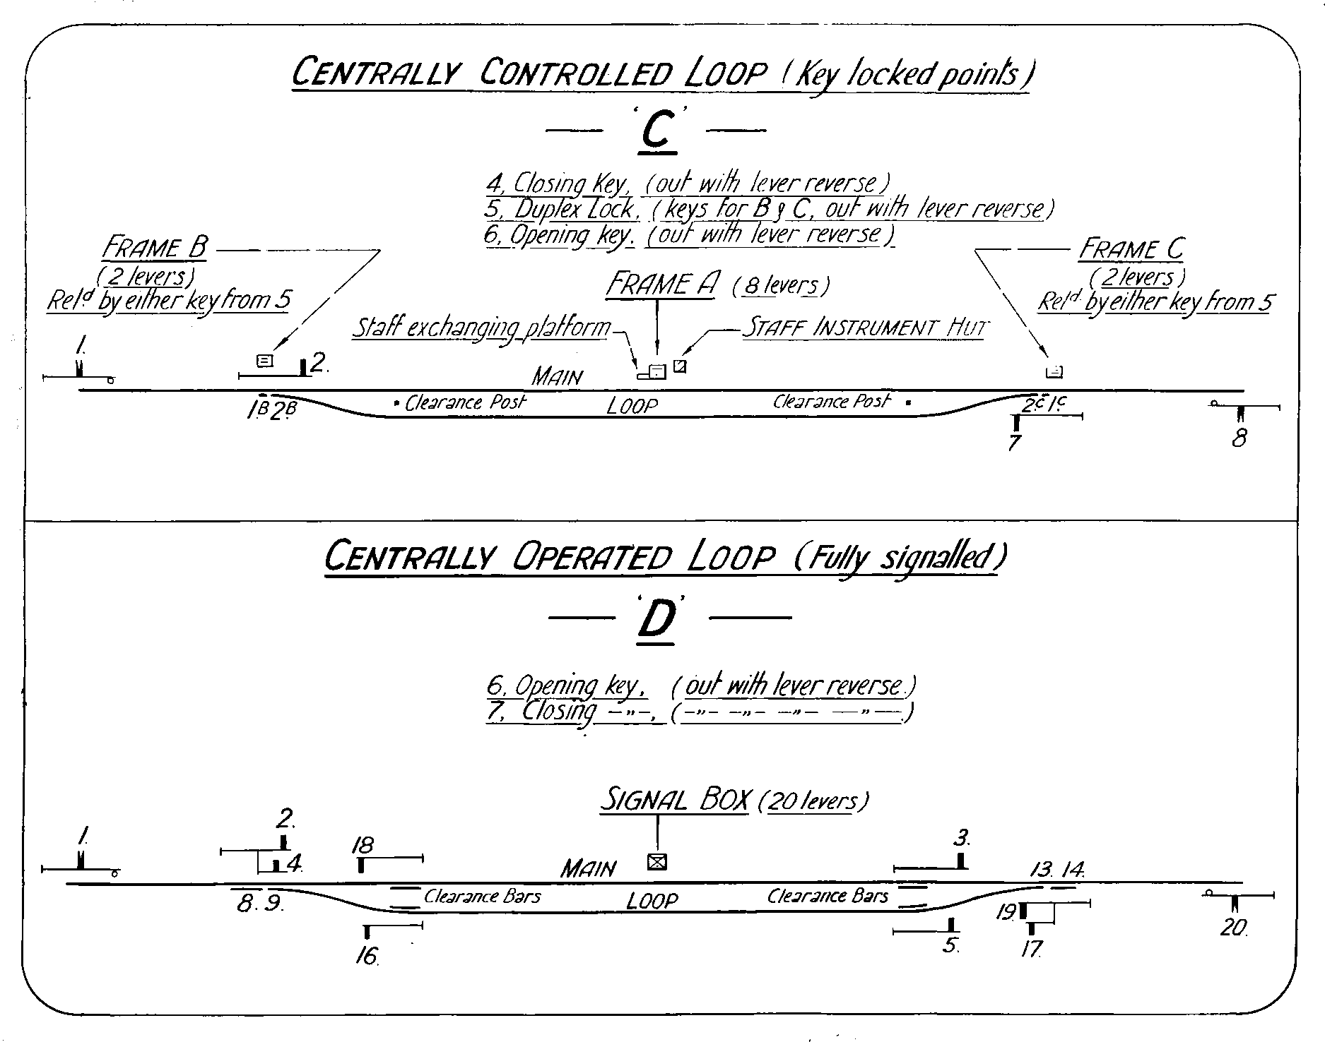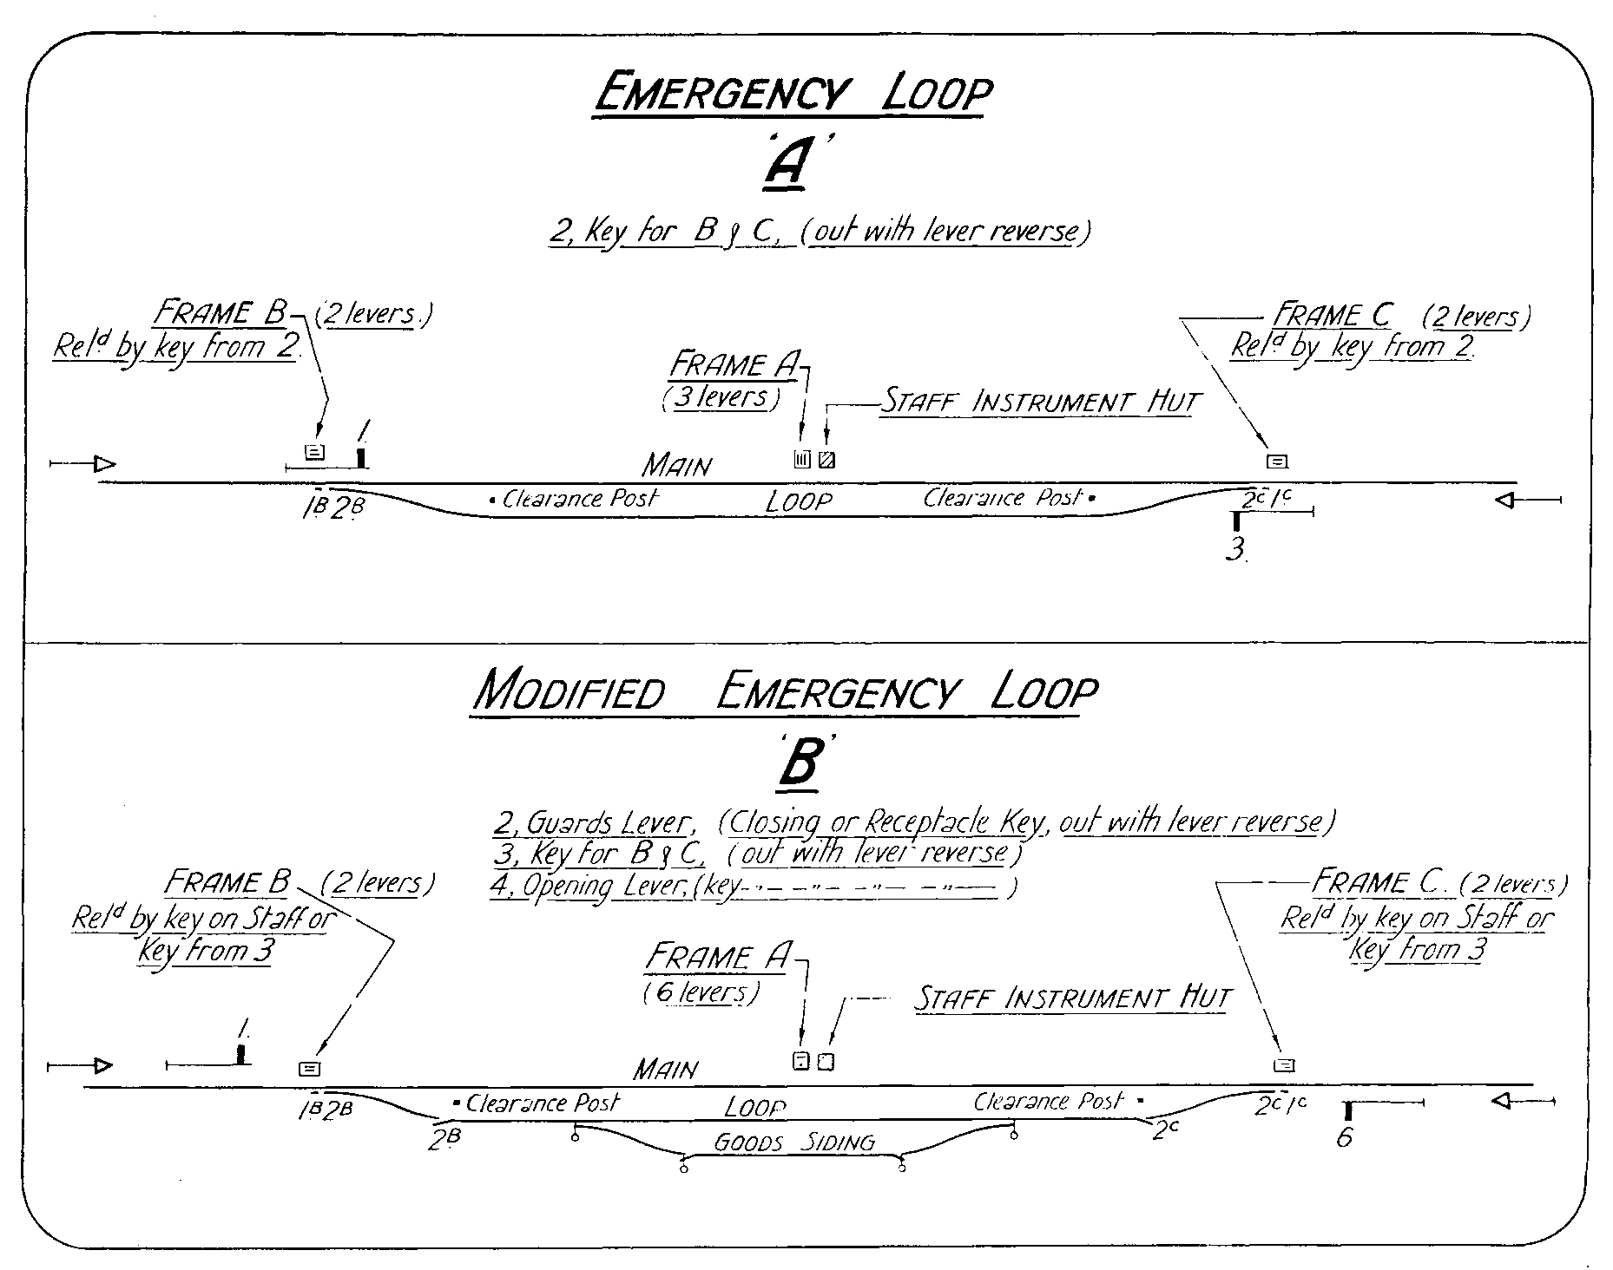

The first consideration, and the one in which the Signal and Telegraph Branch was involved to a very large extent, was the provision of crossing loops to provide additional traffic facilities.

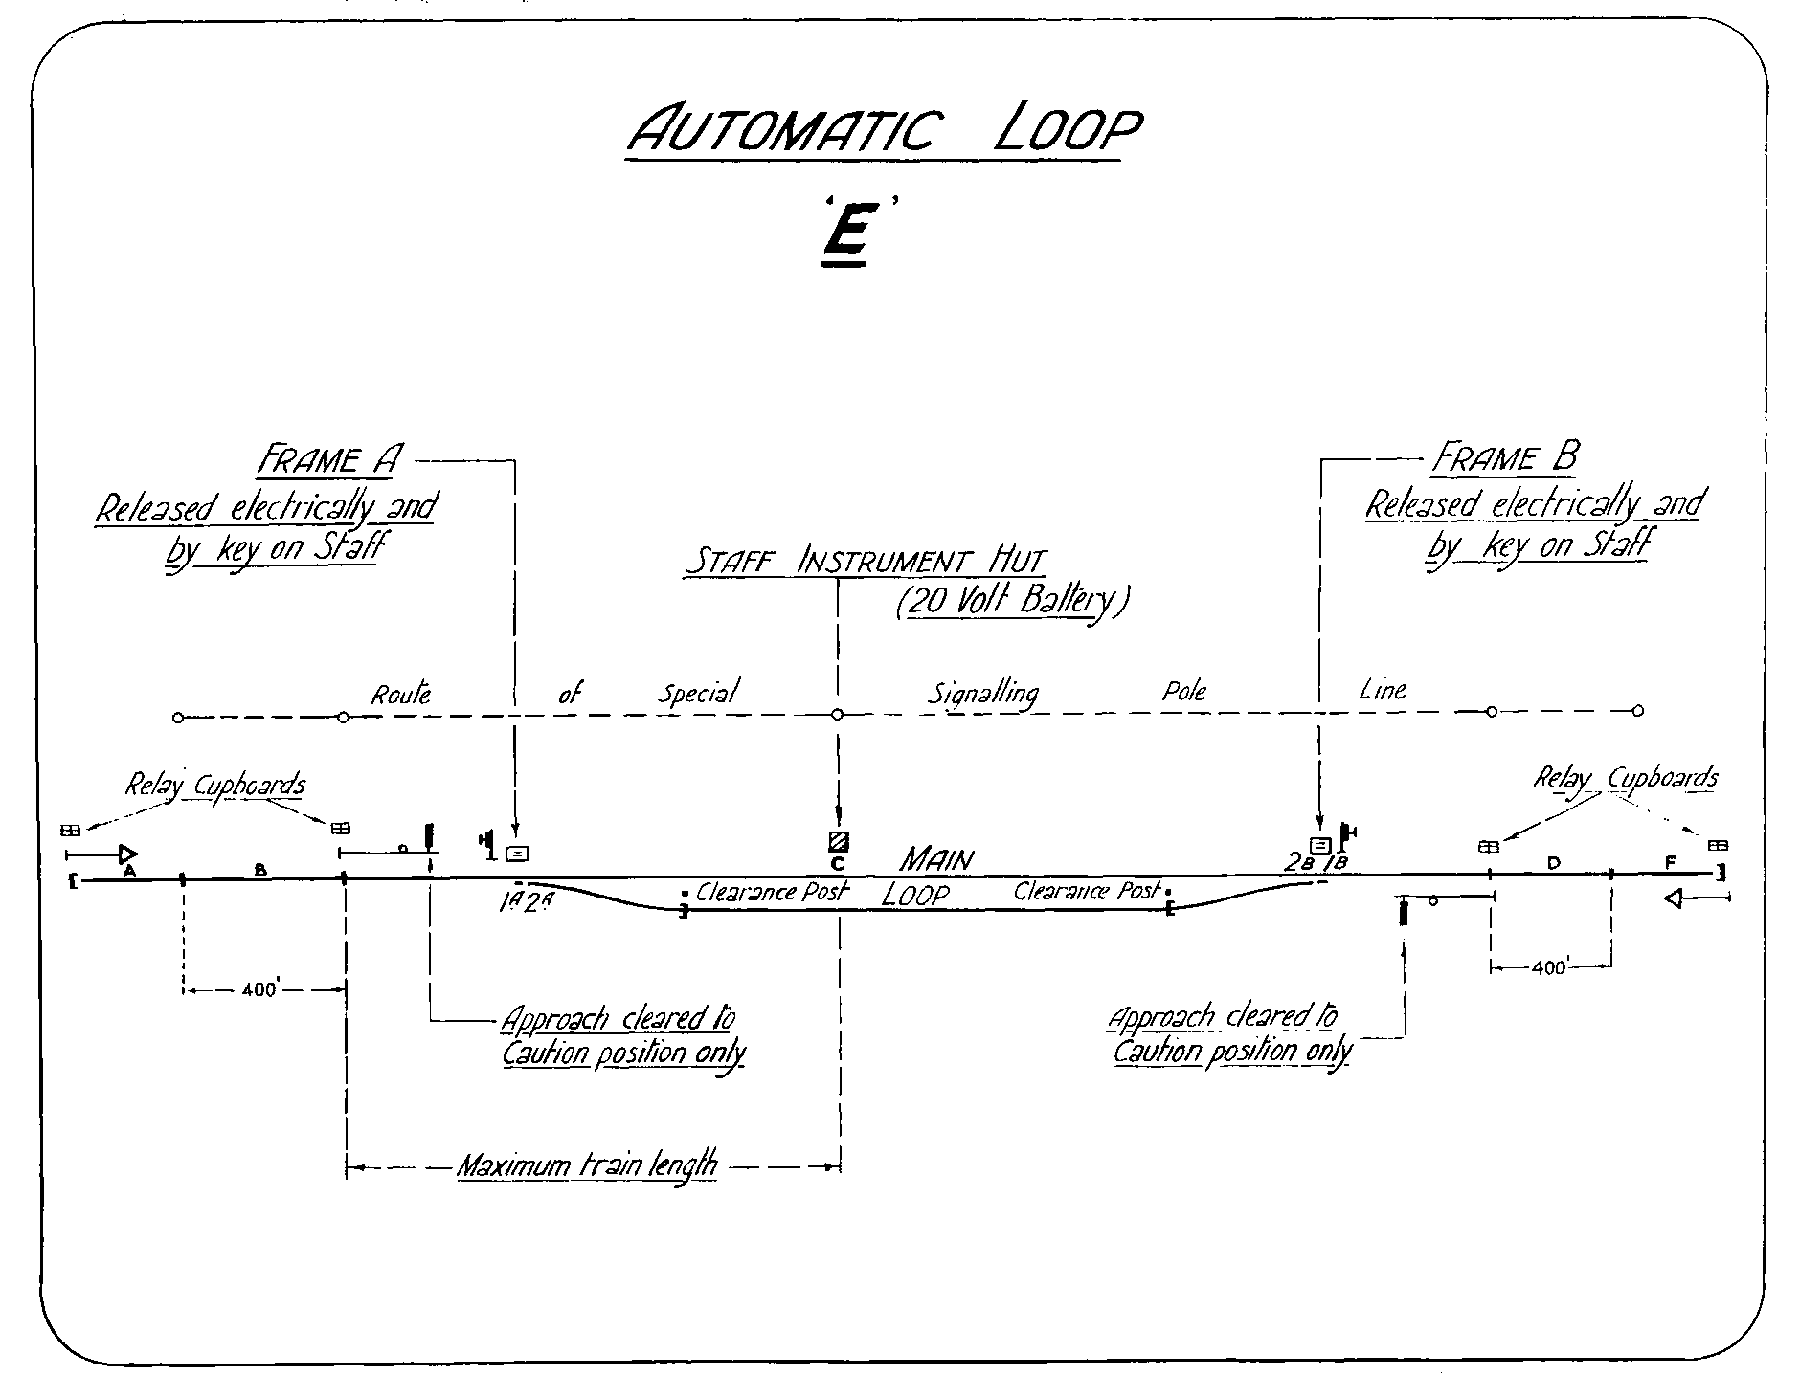As the loops conformed to certain standards, it is proposed, first of all, to describe some typical installations and subsequently, when dealing with specific cases, to make reference to the particular type.

The classification adopted is as follows:

### (A) Emergency Loop

This is a simplified type of loop shown in Diagram.

A 3 lever interlocking machine, located in a central position near the staff hut, serves to control the Home Signals at either end of the loop, and a Key for releasing the Loop points.

Landmark signals are employed as a warning of approach to such a Loop, the triangles are fitted with glass reflectors to avoid the fitting of oil lamps.

The station is closed by pulling over the Key Lever and removing the Key. The Key is retained by the District Signal Branch Officer, and cross boards are fitted to the signals. When open, the Key is secured in the lever by clip and S.L. padlock.

Although many Loops of this type were completed, few were brought into use, as the emergency conditions, for which they were provided, did not eventuate.

Nevertheless, complete arrangements were made, in all cases, for the cancellation of the existing electric or ordinary train staff working, and the division of the through section into two ordinary train staff sections, should the occasion arise.

### (B) Modified Emergency Loop with Goods Siding Connection

An example of this type of loop is shown in Diagram.

On Ordinary Train Staff Sections, signal protection should be afforded trains travelling on a ticket whilst they are shunting intermediate sidings.

A number of existing intermediate sidings on Ordinary Train Staff sections were located at sites selected for the provision of Crossing Loops. In order to meet the above requirements, and also permit closing the Loop when necessary, a modified form of emergency loop was developed.

When the Station is closed, opposing Home signals are cleared and secured by means of a “Closing” or “Guard’s” Lever. The guard of a train requiring to shunt the siding, when the station is closed, uses a Receptacle Key to restore the “Guard’s” Lever and Home signals to normal, thereby releasing the Key Lever for the siding connection. An additional lever, known as an “Opening” Lever is employed to impose the interlocking between Home signals when the station is opened. This lever is secured in the reverse position by an opening Key held by a responsible District Officer.

### (C) Centrally Controlled Loop (Key Locked Points)

In principle, this loop is similar to the Emergency Loop, Type A – see Diagram.

A fully equipped signal box is provided and, when closed, the interlocking machine and staff instruments are worked in accordance with standard regulations.

### (D) Centrally Operated Loop (Fully Signalled)

This is a standard loop, an example of which is shown in Diagram.

### (E) Automatic Loop

The arrangements in this type of loop were specifically designed to avoid staffing and to expedite train movements. An example is shown in Diagram.

The power worked Home signals are located a train’s length out from the central staff hut to ensure that the rear of a train has passed inside the Home signal before the electric train staff is restored to the instrument.

The signals are normally at “Stop” and “approach cleared” by the train. Special circuiting against simultaneous operation or either signal clearing with an opposing train inside the Landmark.

Loop points are also released electrically and interlocked with the staff for the section.

In the case of through trains not requiring to enter the Loop or make a crossing the train is brought to a stand at the staff hut, the staff instruments operated by the fireman under automatic working, and then it proceeds on its way - an operation performed with a minimum loss of time.

A central 20 volt primary battery is used for the control and operation of signals, and five track circuits are required between the two Landmarks. A short approach track circuit, 400 feet, approximately, in length, in the rear of each Home signal serves for approach clearing purposes.

A special signal pole line between Home signals carries the signal control wires.

### (F) Converted Automatic Loop

The converted loop corresponds to the Automatic Loop, Type “E”, and was evolved from the original Standard Unattended Loop.

The Up and Down Line Working of the latter type was changed to Main Line and Loop, existing machines at each end being retained, in most cases, for working the Loop connections.

The new arrangements avoided the double stop for each train which had proved a great disadvantage with the old type of loop, and at the same time allowed greater flexibility for traffic working.

## 3 Broken Hill – Parkes

The maximum capacity of this line, on the Declaration of War, was 3 Up and 3 Down Through Goods trains per day. Allowing for servicing the section with at least two pick-up trains per week and one water train per day, this represented a clearance capacity of 12,000 tons per week ex Broken Hill.

An Inter-Branch Committee, after careful survey of the position, and, in the knowledge that 16,000 tons were to be handled from Broken Hill, decided that traffic facilities were required for 7 Up and 6 Down Through Goods trains and one water train per day.

To achieve this object, the provision of additional crossing loops was undertaken in January 1941, and by June of that year the following loops were completed:

Koroo Gibbial

Yarrabandai Conoble

Derriwong Oricar

Yeenan Jamma

Gunebang Diwarra

Boonia Box Tank

Mirrabee Tiuna

With the exception of Yarrabandai, Derriwong, Gunebang and Box Tank, all were of the emergency type as described in “A” of the Typical Loops.

These latter loops conformed to the modified emergency type of Loop, Type “B”.

Conoble consisted, originally of a Loop Goods Siding operated by key on the Electric Train Staff. To meet the emergency conditions it was converted to a crossing loop, 1715 feet in the clear, of the emergency type “A”, and since October 1941, has functioned as a permanent crossing station, thereby dividing the long 41 mile section Trida - Ivanhoe.

Apart from Conoble, the only loops brought into use were Box Tank and Tiuna which were opened for the heavy water lift traffic between Menindee and Broken Hill during the drought of 1944-1945.

Extensions to existing Loops were carried out at Bogan Gate, Condobolin, Euabalong West, Ivanhoe and Menindee. These works involved the provision of new signals and/or refixing existing ones together with the relocation of ground frames and point connections.

Additional crossing facilities were provided, also, at Roto, an existing staff station.

Five gangs, in all, were employed, each consisting of a Signal Ganger and four other grades, and the whole of the work was completed within four months, which is no small achievement considering the distance to Sydney and the limited transport available on the 422 mile section.

Careful planning was necessary to enable the signal work to coincide with Permanent Way alterations. This applied, not only to local arrangements, but also to the ordering and despatch of material from Sydney and the subsequent distribution on the ground.

Some special features in the construction of the Loops were:

1. Recovered tramway trolley wire poles were used as signal posts.
2. The staff huts were built at Parkes Depot where they were wired and fitted with telephones and Ordinary Staff Boxes prior to despatch. The timber was purchased locally.
3. Ground pattern machines were used for the central frames at Emergency Loops.

### 3.1 Telephone Facilities

For some years prior to commencement of hostilities the telephone train control system was in operation between Orange and Condobolin.

Early in 1940, however, it was recognised that extensions would be required and a pair of copper wires was erected between Condobolin and Broken Hill. The Control System was extended to Ivanhoe and all intermediate stations were connected, including the new Crossing Loops. Beyond Ivanhoe no ringing facilities were provided on the new circuit, but Orange Control could speak to any station after contacting Ivanhoe and requesting the Station Officer to ring the station required on the Omnibus Circuit.

### 3.2 Broken Hill

The signalling, in connection with the Exchange Sidings, was brought into use in February 1942. Down and Up signals were provided to protect movements between the Station Yard and the Sidings and a Shunter’s Lever was provided to control the Down Home signal whilst shunting moves are being made in the Exchange Sidings.

In May 1944, a siding was brought into use for the Zinc Corporation. This siding, which is 1m 25c in length, crossed the Silverton Tramway and South Road, necessitating the provision of both railway and flashing light highway signals controlled from a new Signal-box.

### 3.3 Parkes

The removal of the locomotive depot at Parkes to a new site, approximately 1/4 mile west of the station, made available additional space for traffic sidings in Parkes Yard which entailed alterations to layout and signalling.

Furthermore, in order to handle, satisfactorily, the movements of engines between the Yard and the new depot, as well as trains over the Parkes - Goobang Junction section, together with the passage of road vehicles over the Newell Highway Level Crossing, it became necessary to erect a new signal box.

Provision had to be made for signalling the new layout of the Yard, track block working between Parkes and Goobang Junction, power operation of the points leading into the locomotive depot and boom gates for the protection of the Level Crossing.

In view of the electrical controls associated with the above requirements, it was decided to install an electro-mechanical machine consisting of 24 miniature electrical and 56 mechanical levers.

Extensive track circuiting was involved. Save for a short length of track from the Sydney end of the platform to a point immediately west of the Signal Box at the level crossing, the Main Line is track circuited from the power worked Down Home signal at East Street to Goobang West, a distance of 2 1/4 miles. Electric Releasing Switches were provided for the connections at the Sydney end of the Yard to accelerate shunting movements.

Mechanically operated booms were installed and, as at Parramatta Road Crossing, Clyde and at Tarcutta Road, they have provided very successful.

A new signalling pole line was erected between the Signal-box and Goobang West carrying, in addition to signal controls, the power lines for normal and emergency operation of the motor worked points and Signal-box equipment.

Extensive additions and alterations were made to the existing poles at the Sydney end.

Work was commenced in August 1943, and the complete installation was brought into use in July 1944.

## 4 Tocumwal - Narrandera

The Main Southern Line, having reached saturation point on the single line section from Cootamundra to Albury, it was realised, at the outbreak of war, that heavy interstate traffic would be handled on the Tocumwal - Narrandera section, and plans were made accordingly. In consequence, certain additional facilities had been provided before the major question of the diversion of sea-bourns traffic was considered late in 1940.

Three new crossing loops were completed in July 1940, viz. Mairjimmy, North Yathong and Corobimilla. All were modified emergency Type “B” Loops and, in each case, extensions, involving the re-location of the signals and ground frames, were carried out the following year, so great was the increase in traffic.

At Finley, Berrigan, Jerilderie and Bundure, facilities were provided for the crossing of passenger trains and full length goods trains where, before, only goods trains, of limited length, were permitted to cross. Berrigan and Jerilderie were non-interlocked and during the course of the new work the loop points were interlocked and worked from a ground frame, Key released from the main frame. The pullover type of levers at Jerilderie were replaced by a 6 lever machine. The extensions and re-arrangements at each of these stations necessitated the provision of new signals and refining existing ones.

The provision of a Transhipping Yard and Exchange Siding at Tocumwal, following the completion of a new platform on the Sydney side, and the removal of the Locomotive Depot to a new site, were works which extended over a long period, and involved a certain amount of signal alteration, including a new machine on the Victorian platform.

To permit of moves to and from the new Sidings, however, Electric Train Staff working was required on the section approaching Tocumwal. A new crossing loop was provided at Langunyah, and this station became the dividing point between Ordinary and Electric Train Staff sections. Two Intermediate instruments were provided on the new section for working the Sidings.

The signalling alterations at Langunyah are of the emergency loop Type “A” with an open frame. The Closing lever locks the Home signals in either position.

Additional siding accommodation was provided at Narrandera, together with additional signals, to facilitate movements to and from the Hay and Tocumwal Lines.

This work involved the re-numbering of a large subsidiary ground frame in the Yard and the provision of an electrical release for the new crossovers between the two lines.

### 4.1 Telephone Facilities

The only communication between Narrandera and Tocumwal prior to 1940 was by means of a Morse Line on Postal poles.

A Pole Line carrying one pair of wires was erected between the two stations in 1940, and a local telephone circuit connecting will all stations, which also functioned as a Train Control circuit, with Junee the Controlling Station, was brought into use.

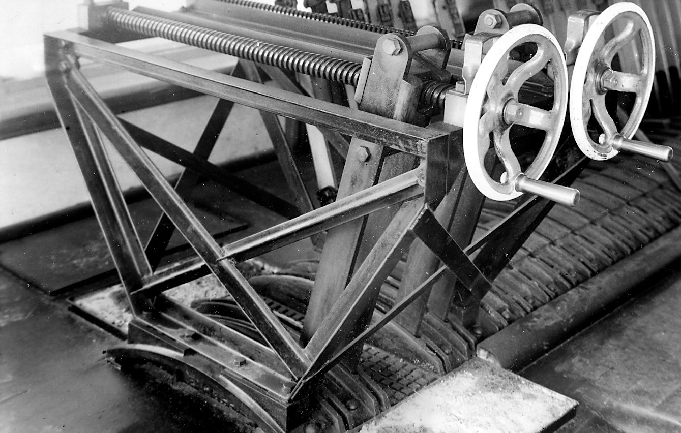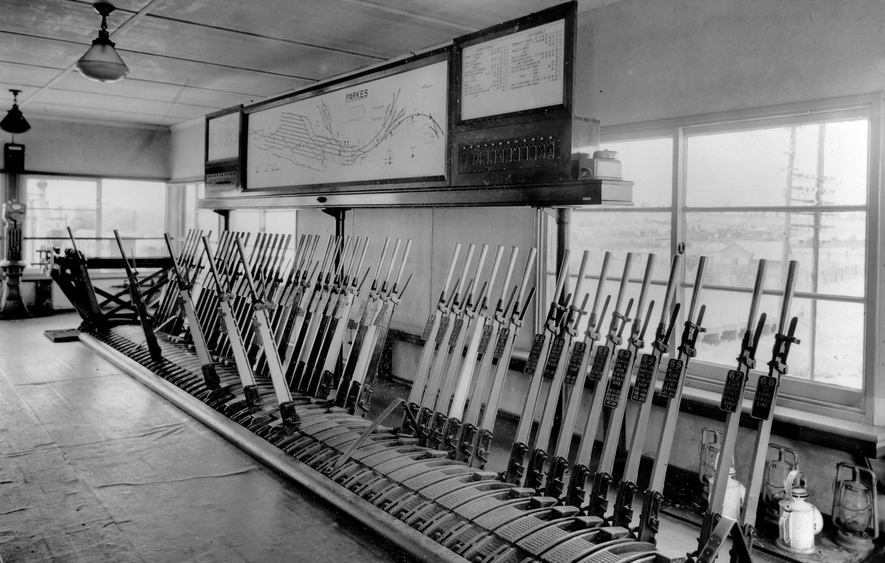

(Above) Parkes – the interior of the new signal box with a large standard mechanical frame, a combined track circuit and box diagram. On either side of the diagram is the pulling list and the Kellogg Key panels. The bell at the nearest end of the diagram is a block bell to announce trains to the signalman at Goobang Juntion. At the far end of the frame is the NSWR style gate wheels to work the boom gates. To the left hand end is a MES instrument. The Kellogg Key panels were co-numbered with the mechanical levers. (Below) Parkes – Gate wheel. This style of gate wheel appeared about the early 1940s and remained in use for new installations until about 1952. This example has a fabricated framework, but at least one example had a cast framework.

The increase in traffic was such that in 1943 it became necessary to separate these circuits and an additional pair of wires was erected for Train Control. A trunk line was obtained between Narrandera and Tocumwal by superimposing between the two pairs.

The services provided were as follows:

1. Control Line Tocumwal to Narrandera, linked with Narrandera to Junee Control
2. Trunk Line Tocumwal to Narrandera, linked with Narrandera to Junee Trunk line

Omnibus telephone service Tocumwal all stations to Narrandera, connected to Junee with one of the existing services.

During the course of the erection of the pole line, in 1940, difficulty was experienced in obtaining tallow wood crossarms, and a special cast iron crossarm was designed to carry two wires. This type of arm was used, also, for the additional circuit in 1943 and, in all, some 5400 were used, together with 448 miles of copper wire.

## 5 Narrandera – Griffith – Stockinbingal – Parkes

Work was proceeding on this section simultaneously with that on the Broken Hill - Parkes section and between July and September 1941, four new automatic crossing loops, Type “E”, were completed and brought into use. These were Canal Loop, Murrami and Wumbulgal, between Narrandera and Griffith, and Pucawan, between Griffith and Temora.

The opening of the automatic crossing loops at Canal Loop and Pucawan necessitated the replacement of the existing Ordinary Train Staff Working by Electric Train Staff Working, and accordingly, the Ordinary Train Staff section Narrandera - Yanco was replaced by the Electric Train Staff sections Narrandera - Canal Loop and Canal Loop - Yanco.

Similarly the Ordinary Train Staff section Ariah Park - Temora was replaced by the Electric Train Staff sections Ariah Park - Pucawan and Pucawan - Temora.

This involved the provision of eight additional Electric Staff instruments and the erection of two additional G.I. line wires over each section, a total distance of 34 miles.

New crossing loops were provided, also at Binya, Tigan and Mirrool, whilst Springdale, which had been out of use for a long time, was altered and extended and brought into use as a crossing station of the modified emergency Type “B”. The loops at Binya and Mirrool were emergency Type “A”, and Tigan was originally opened as such, but, subsequently, altered to the modified emergency type with a six lever machine.

These loops were opened when necessary and Binya, which was opened in 1942, is still in use.

At Ariah Park, a new Up Refuge Loop between the Main Line and the Engine Triangle necessitated new connections for the latter and moving the Up Home and Landmark signals.

Direct access from the Narrandera to Temora line at Griffith and from the Temora to Parkes line at Stockinbingal was provided by triangle at Griffith and Stockinbingal.

Double lines were installed at Griffith and protection was afforded by signals at each end controlled from a central box. Intermediate staff instruments for the respective sections on the Narrandera and Temora lines were provided to accelerate the movements.

At Stockinbingal a single line, only, was installed, for which an Ordinary Train Staff was provided. The connection at the Temora end was unlocked by Key on the Ordinary Train Staff for the section Temora - Stockinbingal and at the Forbes end an intermediate staff instrument served the dual purpose of giving authority to enter the section to Milvale and to unlock the ground frame.

### 5.1 Stockinbingal - Parkes

Between Stockinbingal and Parkes the existing facilities were adequate to meet the demands made upon them and no alterations were made.

### 5.2 Telephone Facilities

Between Temora and Griffith the Train Control Telephone Service was obtained by using the local telephone circuit and this system was capable of handling the business until 1944, when the increasing volume of traffic made it necessary to separate the two circuits. This entailed the erection of an additional pair of copper line wires over a total distance of 94 miles. The work was completed and separate circuits brought into use in May 1945.

### 5.3 Parkes - Narromine

Additional crossing loops were provided at Nanardine, Mickibri, Myaroo and Narromine.

The Loops at the three former stations conformed to Type “A” in all respects but were located within Electric Train Staff sections and for that reason did not require any special opening and closing arrangements for operation of the Goods Siding connections.

Six new staff instruments were required together with an intermediate staff instrument for the Narromine Loop.

Nanardine, Mickibri and Myaroo have been retained as permanent crossing stations.

### 5.4 Telephone Facilities

Prior to 1940 the Train Control Officer at Dubbo used the Omnibus Telephone Circuit between Narromine and Parkes, but traffic grew to such an extent in this year that a pair of copper wires was erected to extend the Train Control System directly to Parkes.

## 6 Dubbo – Werris Creek

Extensive signalling alterations were necessitated by the provision of Branch Storage Sidings adjacent to Dubbo Triangle. This work involved the replacement of a 16 lever subsidiary machine with a 24 lever machine, with consequent re-numbering of all functions. The chief difficulty to be overcome was to keep all equipment in service whilst the change-over was taking place.

An intermediate staff instrument was provided at the Troy Junction end of the triangle to facilitate this working.

The work on this section is noteworthy in that the first automatic loop, Type “E”, installed on these railways, was completed at Piambra in May 1940. Closely following this work were similar installations at Premer, Toogarlan and Bakana.

In addition, emergency loops, Type “A” were provided at various Goods Sidings throughout the section, viz.:

Boothenba Ulinda

Muronbung Oakey Creek

Kamilaroi Tamarang

Mendooran

All of these loops were in use at various times and Electric Train Staff working was suspended and trains worked over the divided sections by Ordinary Train Staff.

A short distance from Werris Creek, at Gap, the Inverell and Dubbo lines converge and advantage of this was taken to install a crossover between the two lines. This permitted trains to proceed directly from Binnaway to Sydney without reversal in Werris Creek Yard.

Two intermediate staff instruments were provided adjacent to the crossing and, to operate the connection, both staffs were used in a Duplex Lock on the facing point lock lever.

The lengthening of the crossing loop and the provision of additional siding accommodation at Binnaway entailed considerable signalling work including a new 16 lever machine which replaced a 12 lever.

The improved traffic working, which resulted from the provision the automatic type of loop, led, subsequently, to the conversion of all the old standard unattended loops, on this section, to the new automatic type.

This work was carried out over a period extending from January 1944 to June 1945, and therefore does not come within the category of work performed for the diversion of sea-borne traffic.

The loops concerned were as follows:

Barbigal Weetaliba

Caratel Yannergee

Neilrex Caroona

### 6.1 Telephone Facilities

The Telephone Train control already in service between Dubbo and Binnaway was extended to Werris Creek, thereby linking the Western and Northern Controls.

A pair of wires was erected for this purpose between Binnaway and Werris Creek and another pair of wires between Dubbo and Binnaway enabled the extension of the Werris Creek - Binnaway Telephone Circuit to Dubbo.

## 7 Werris Creek – Newcastle

The final section to be dealt with on the cross-country route from Broken Hill and Tocumwal to Newcastle is the Main Line portion from Werris Creek to Newcastle.

Two centrally operated loops, Type D, were provided, viz. Braefield and Liddell. A motor operated distant signal was provided at Liddell another feature of which was the high concrete foundation required for the Signal box, located in a cutting.

Existing loops at Kankool, Ardglen, Pangela, Togar and Koolbury were converted from Up and Down Main working to Main and Loop working, centrally operated. The conversions necessitated extensions to the interlocking machines and the provision of 27 new signals in all.

## 8 Summary

The foregoing covers, briefly, the signalling work involved in making provision for anticipated cross-country traffic.

With the exception of Broken Hill, Tocumwal and Parkes, most of the work was completed within twelve months during 1940-1.

The following summary gives some idea of the volume of work executed:

**New Crossing Loops**

Type “A” 23

Type “B” 8

Type “D” 2

Type “E” 8

Converted to Type “D” 5

Special (Griffith and Narromine) 2

Total 48

Electric Train Staff instruments provided 32

Intermediate ETS instruments provided 9

# Collision at Riddells Creek

Continued from Page 93

In 1876, Victorian trains were entirely hand braked. Even steam brakes on the locomotives were not fitted (these would not start to be fitted until 1879). Varying the brake power whilst running was dependent on the train crew operating hand brakes in the vans and on the locomotive, and the stock special had two ‘heavy’ vans under the control of a head Guard and an assistant Guard for this purpose. One feature of traditional railway brakes is that they ‘fade,’ or become less effective, quickly as the wheels heat up. In descending the Riddells Creek bank the brakes on the locomotive and the two Guards Vans must have been constantly in use merely to control the speed of the train. These two features would have meant there was little braking power left in reserve to actually stop the train at Riddells Creek. Hence the requirement to drop sufficient brakes at the top of the grade to assist in controlling the speed of descent.

The report suggest that block telegraph was already in use on the Woodend – Macedon and Lancefield Road – Sunbury section, and was established on the Gisborne – Riddells Creek section during September 1876.